Santa Rosa:

Catholic Charities
Samuel L. Jones Hall/Shelter
4020 Finley Ave
Santa Rosa, CA 95407

Catholic Charities
The Palms Inn
3345 Santa Rosa Ave.
Santa Rosa, CA 95407

Iglesia de Restauracion
Puente de Fe
920 Link Lane
Santa Rosa, CA 95401

Resurrection Parish
Catholic Church
303 Stony Point Road
Santa Rosa, CA 95401

Redwood Gospel Mission
101 6th Street
Santa Rosa, CA 95401

Roseland Village
883 Sebastopol Road
Santa Rosa, CA 95407

Windsor:

Windsor Presbyterian Church
251 Windsor River Road
Windsor, CA 95492

Sonoma:

La Luz Center
17560 Greger Street
Sonoma, CA 95476

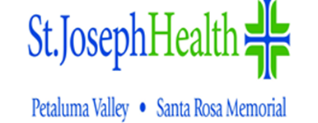

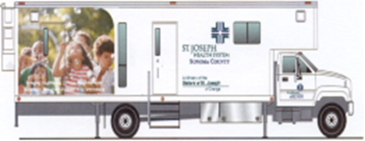

Mobile Health Clinic

Schedule

Horario De

La Clinica Movil

1450 Medical Center Dr.
Rohnert Park, CA 94928
707-547-4612
707-522-1279 Fax
Health.Mobile@stjoe.org

